**ASSIGNMENT 1 –**

1. **How Internet works ?**

The Internet works by connecting networks together through a series of routers and switches. A router forwards packets of data between different networks while a switch links devices within a single network. This enables computers to communicate with each other and access content stored on remote servers.

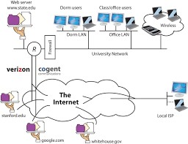

1. How Browser works ?

 When a browser visits a server for data, the web address tells the browser where to look for each item that is described in the html, which then tells the browser where it goes on the web page.

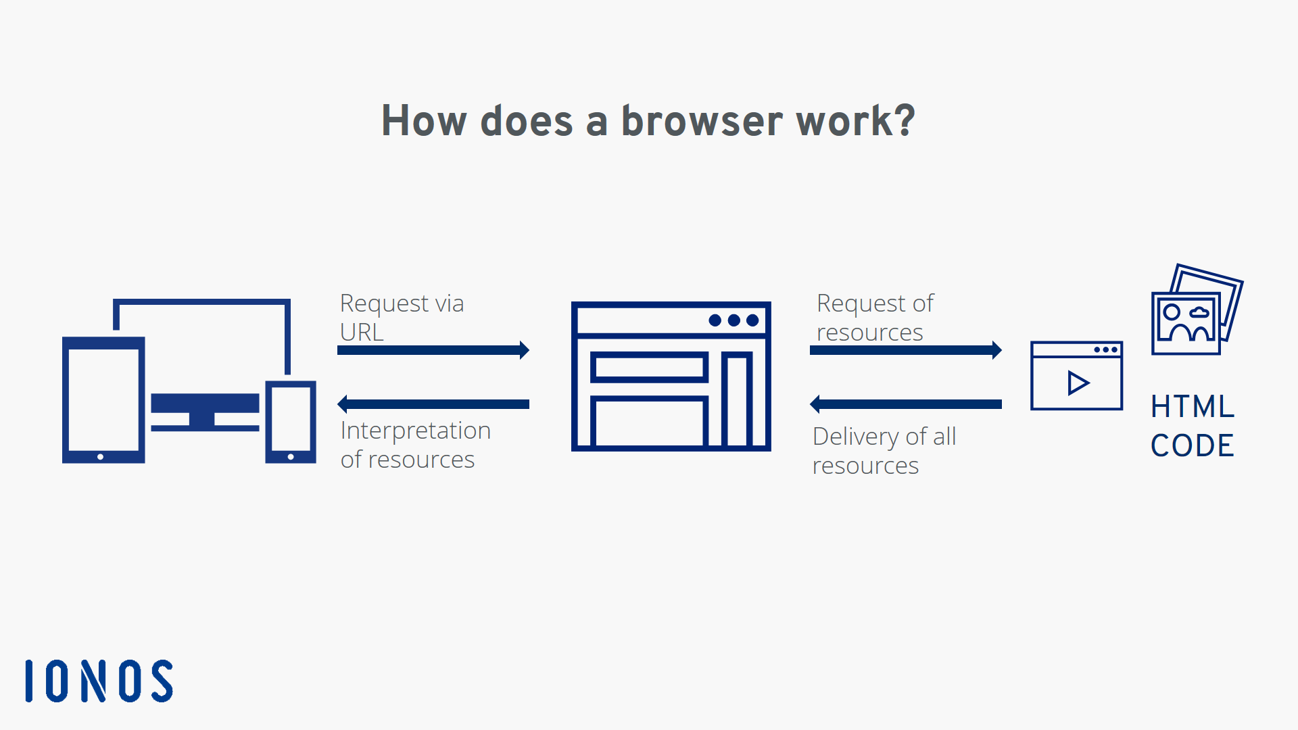

1. **What is Server ?**

A server is a computer or system that provides resources, data, services, or programs to other computers, known as clients, over a network.

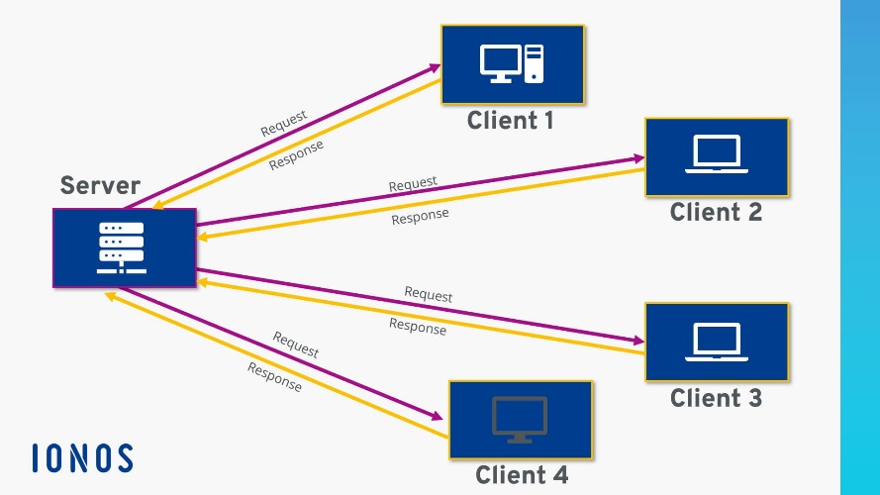

1. **What are the types of server available?**

. The most widely used types of servers are as follows:

1. Web Server
2. Database Server
3. Email Server
4. Web Proxy Server
5. DNS Server
6. FTP Server
7. File Server
8. DHCP Server
9. Cloud Server
10. Application Server
11. Print Server
12. NTP Server
13. Radius Server
14. Syslog Server
15. Physical Server

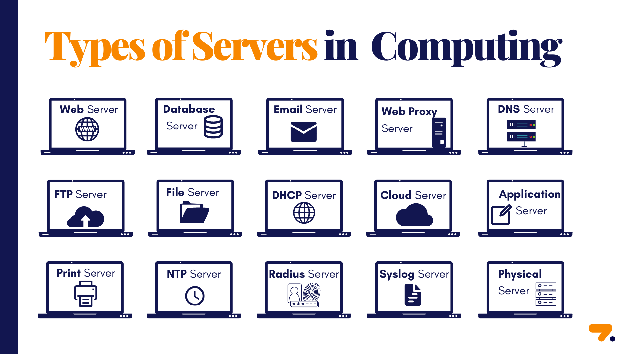

1. What is SEO? Importance of SEO ?

Search engine optimization (SEO) is a set of methods aimed at improving the ranking of a website in search engine listings, and could be considered a subset of Internet or Web marketing. The primary purpose of SEO is to get higher rankings on search engines which in turn creates a larger target audience.

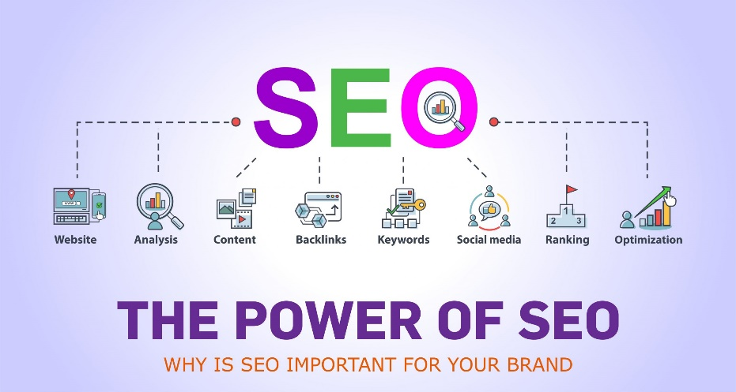

1. What is Accessibility?

Accessible means a person with a disability is afforded the opportunity to acquire the same information, engage in the same interactions, and enjoy the same services as a person without a disability in an equally effective and equally integrated manner, with substantially equivalent ease of use.

1. What is Markup Language?

A Markup language is a system of annotating a document to describe its structure and presentation. It uses tags or codes to define elements such as headings, paragraphs, lists, images, links, and more.

1. What is HTML?

HTML (Hypertext Markup Language) is a text-based approach to describing how content contained within an HTML file is structured. This Markup tells a web browser how to display text, images and other forms of multimedia on a webpage.

1. What is browser engine?

A browser engine (also known as a layout engine or rendering engine) is a core software component of every major web browser. The primary job of a browser engine is to transform HTML documents and other resources of a web page into an interactive visual representation on a user's device.

1. What is rendering engine?share the available rendering engine?

Rendering Engine. As the name suggests, this component is responsible for rendering a specific web page requested by the user on their screen. It interprets HTML and XML documents along with images that are styled or formatted using CSS, and a final layout is generated, which is displayed on the user interface.

11)What is Javascript Engine? Share the available JS engine?

A JavaScript engine is a software component that executes JavaScript code. The first JavaScript engines were mere interpreters, but all relevant modern engines use just-in-time compilation for improved performance. JavaScript engines are typically developed by web browser vendors, and every major browser has one.

12)How website works?

A website is like a book. And its pages are called ‘webpages’. Just like different books may have different numbers of pages, different websites also have different numbers of web pages. A website can have one or one thousand web pages. And just like different pages may have different text or pictures, different web pages also may have different text or pictures or videos or something else.

13)What is Data Structure?

*A data structure is a way of organizing and storing data in a computer so that it can be accessed and used efficiently. It refers to the logical or mathematical representation of data, as well as the implementation in a computer program.*

*14)Explain Tree Data Structure?*

A tree data structure is defined as a collection of objects or entities known as nodes that are linked together to represent or simulate hierarchy. A tree data structure is a non-linear data structure because it does not store in a sequential manner.

15) What is user agent? Share the list and purose?

The User-Agent (UA) string is contained in the HTTP headers and is intended to identify devices requesting online content. The User-Agent tells the server what the visiting device is (among many other things) and this information can be used to determine what content to return.

### Purpose of User Agents:

1. **Server-Side Processing**: Servers use the user agent to determine how to handle and respond to requests. This can involve delivering content tailored to the capabilities or preferences of the user agent.
2. **Statistics and Analytics**: User agents help in gathering statistics about browser usage across the internet, which can inform decisions about web development and design.
3. **Content Negotiation**: It aids in content negotiation, where servers can deliver different versions of content based on the capabilities of the user agent (e.g., mobile vs. desktop browsers).

**16) What is Hypertest**?

Hypertext is a method of organizing information in a digital format that uses traditional text structures (words, sentences, pages, articles or chapters, books, and libraries) as enhanced by the numerous linkages (words to words, words to sentences, sentences to pages, pages to pages, pages to chapters, and so on) that are possible in cyberspace.

17)What is HTML Tags?

HTML tags are composed of an opening tag, content, and a closing tag. The opening tag marks the beginning of an element, and the closing tag marks the end. The content is the information or structure that falls between the opening and closing tags.

18)What is HTML Attributes?

**HTML attributes** provide additional information about elements within an HTML document. Every HTML element can have attributes. Attributes are always defined in the start tag**.**

**19)What is HTML elements?**

An **HTML Element** is a collection of start and end tags with the content inserted between them. HTML elements are building blocks of web pages, representing different types of content such as **headings**, **paragraphs**, **links**, and **images**.

20)How to convert elements to tree?

We will insert the first element present in the array as the root node at level 0 in the tree and start traversing the array and for every node i we will insert its both childs left and right in the tree.

**21)What is DOCTYPE?**

The HTML document type declaration, also known as DOCTYPE, is the first line of code required in every HTML or XHTML document. The DOCTYPE declaration is an instruction to the web browser about what version of HTML the page is written in. This ensures that the web page is parsed the same way by different web browsers.

22)What are the ways we can save html file?

On the main menu, click File > Save. On the HTML editor toolbar, click the Save icon . Press CTRL+S. Right-click within the HTML document, click File > Save.

23)What is charset?why we need to use this?

The charset attribute specifies the character encoding for the HTML document. The HTML5 specification encourages web developers to use the UTF-8 character set, which covers almost all of the characters and symbols in the world!

All of the characters that a computer can use are called a character set. This allows the computer system to convert text into binary. Examples are ASCII and Unicode. .

24)What is meta data? What is the purpose of it?

Metadata is defined as the data providing information about one or more aspects of the data; it is used to summarize basic information about data that can make tracking and working with specific data easier. Some examples include: Means of creation of the data. Purpose of the data.

25)Explain Web application Architecture?

Web application architecture defines the interactions between applications, middleware systems and databases to ensure multiple applications can work together. When a user types in a URL and taps “Go,” the browser will find the Internet-facing computer the website lives on and requests that particular page.

